**LAB BOOK: ORACLE SQL**

**LAB 1**

1. SELECT staff_name, staff_sal, dept_code FROM staff_masters WHERE dept_code IN(20,30,40);

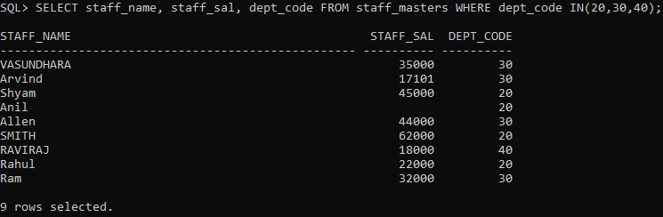

1. SELECT staff_code AS STAFFCODE, staff_name AS STAFFNAME, staff_dob AS STAFFDOB, hiredate AS HIRINGDATE, design_code AS DESIGNINGCODE, mgr_code AS MANAGERCODE, staff_sal AS SALARY, staff_address AS ADDRESS FROM staff_master;

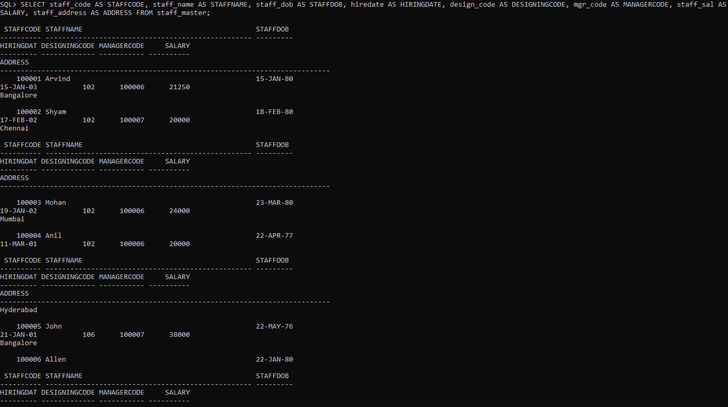

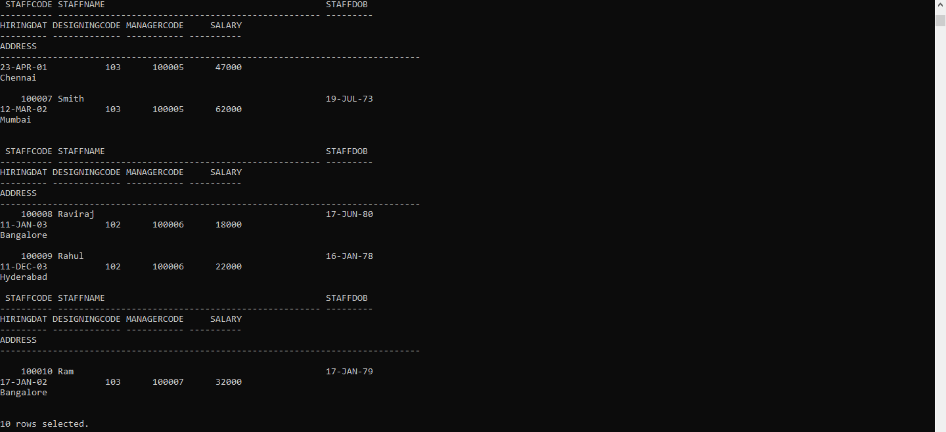

1. SELECT student_code, subject1, subject2, subject3, subject1+subject2+subject3 AS TOTALMARKS FROM student_marks;

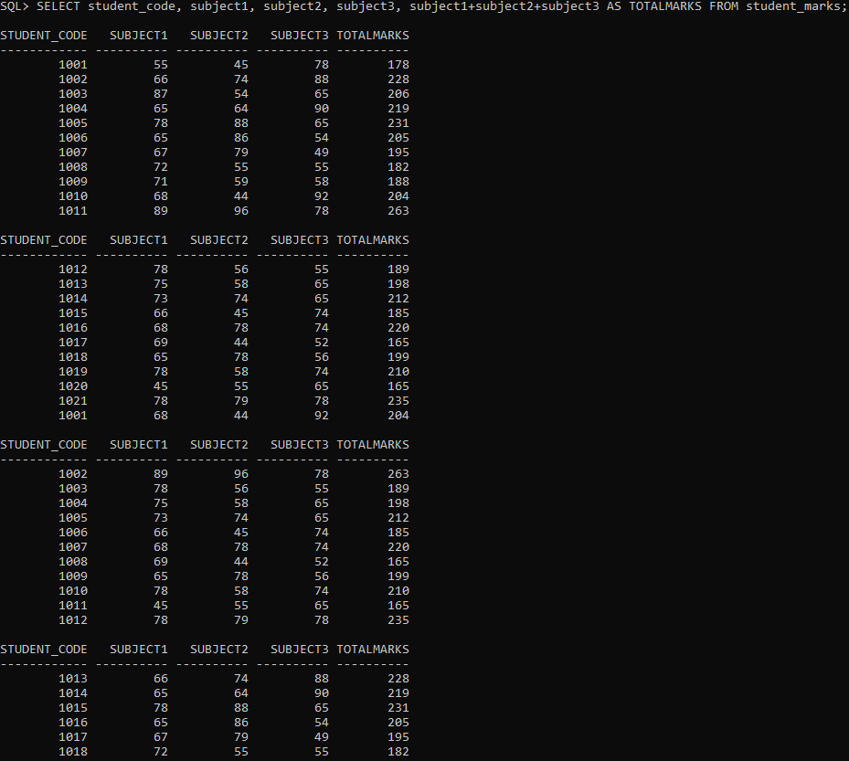

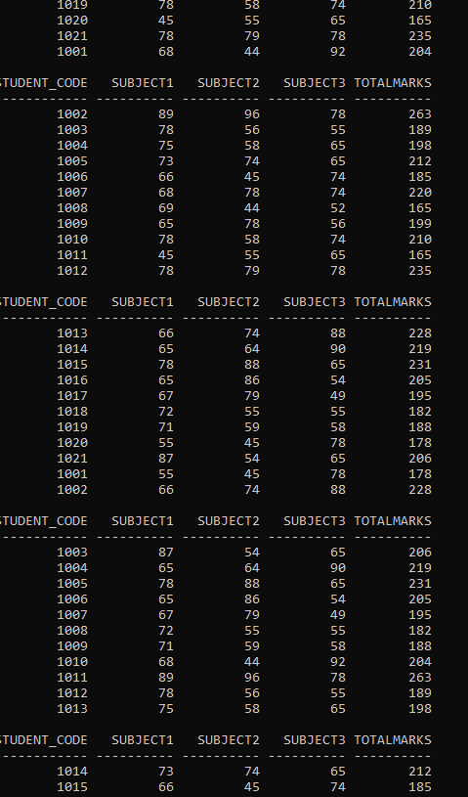

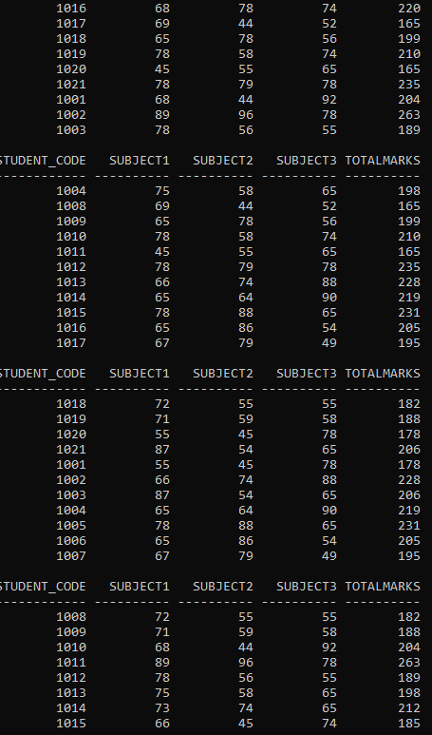

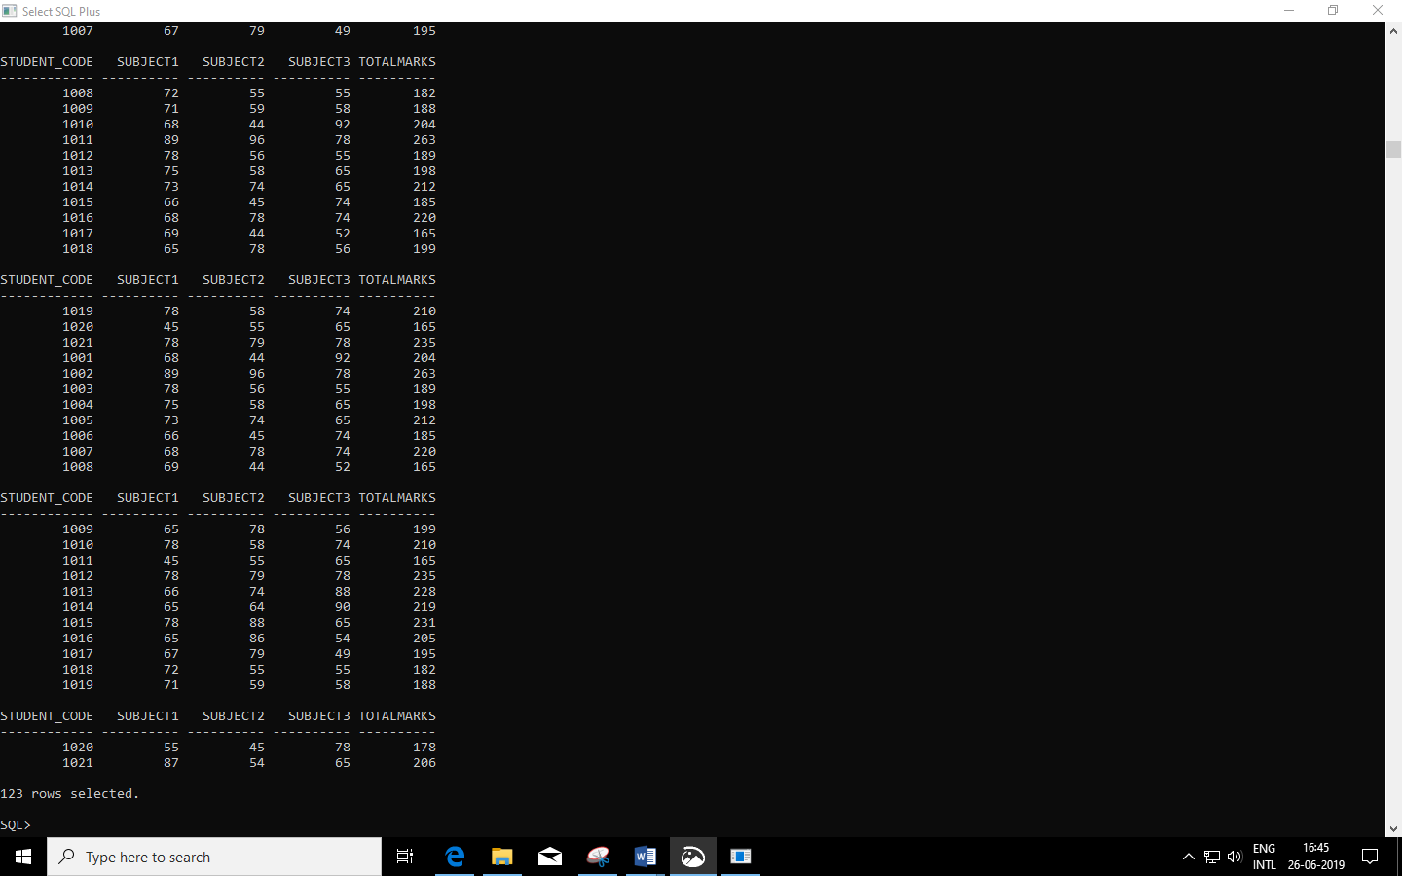

1. SELECT * FROM staff_masters a INNER JOIN designation_masters b ON a.design_code=b.design_code WHERE b.design_name = ´Professor´ OR b.design_name = ´Lecturer´;

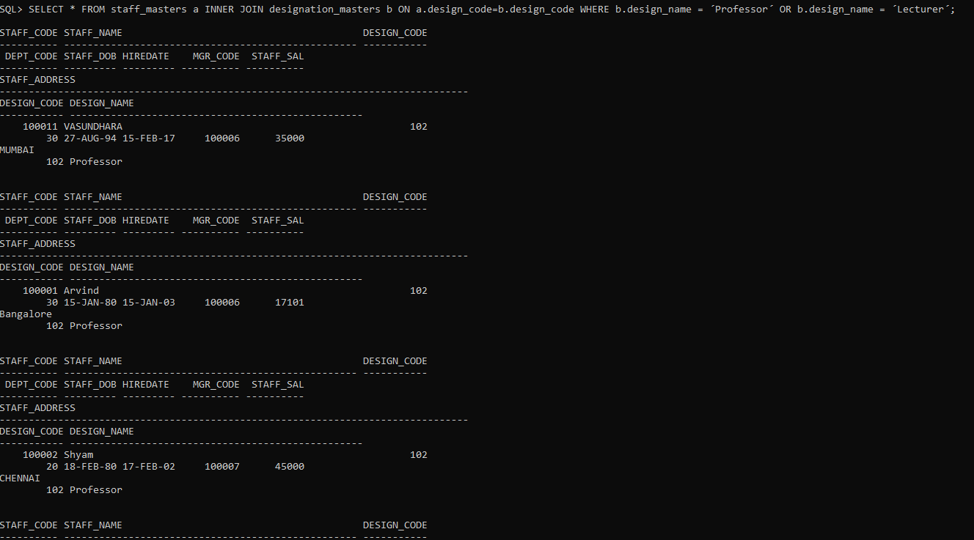

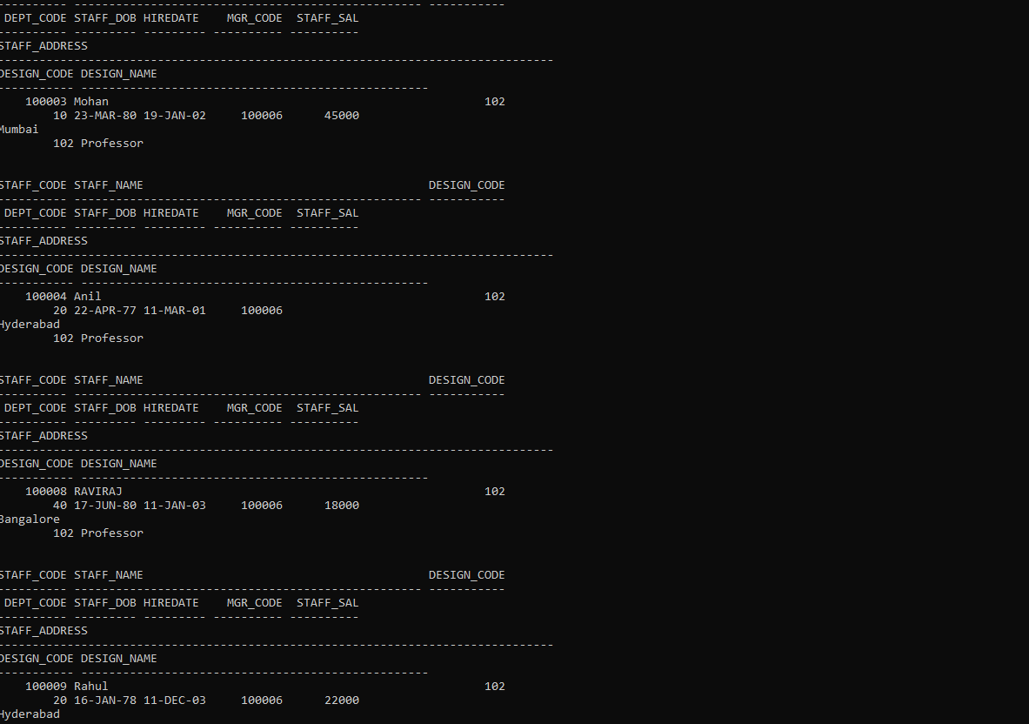

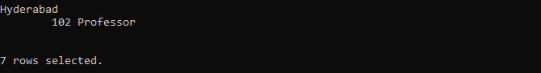

1. SELECT staff_code, staff_name, dept_code FROM staff_masters WHERE TO_CHAR(sysdate,´YYYY´)-TO_CHAR(hiredate,´YYYY´) > 18;

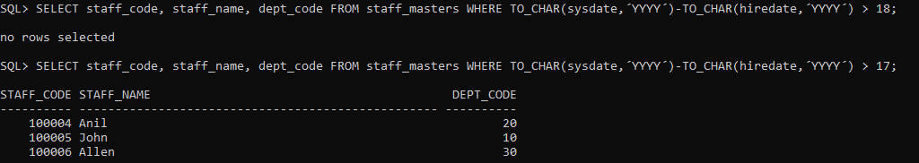

1. SELECT a.staff_name,b.design_name FROM staff_masters a INNER JOIN designation_masters b ON a.design_code=b.design_code WHERE a.hiredate < ´01-Jan-03´;

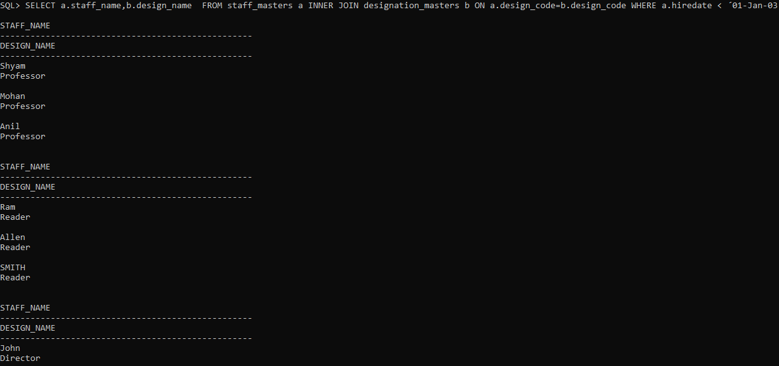

1. SELECT staff_name, design_code, staff_sal*120 AS INCOME FROM staff_masters WHERE dept_code IN(10,30);

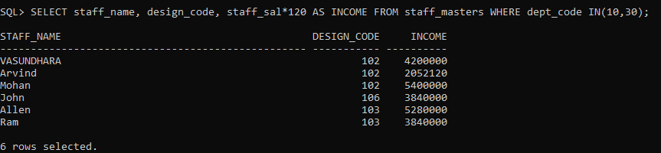

1. SELECT a.staff_name, TO_CHAR(sysdate,´YYYY´)-TO_CHAR(a.hiredate,´YYYY´) AS EXPERIENCE FROM staff_masters a INNER JOIN designation_masters b ON a.design_code = b.design_code WHERE b.design_name = ´Lecturer´;



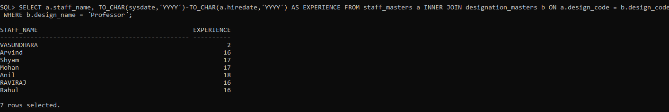

1. SELECT student_name||', '|| dept_code AS STUDENT_INFO FROM student_masters;

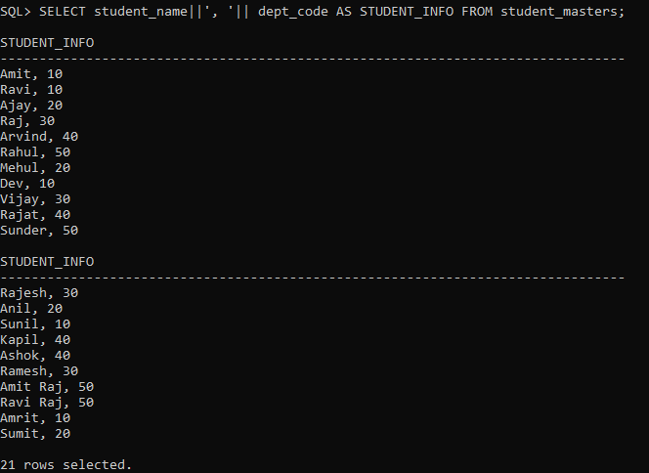

1. SELECT staff_name, staff_sal FROM staff_masters WHERE staff_sal BETWEEN 12000 AND 25000 ORDER BY staff_name, staff_sal;

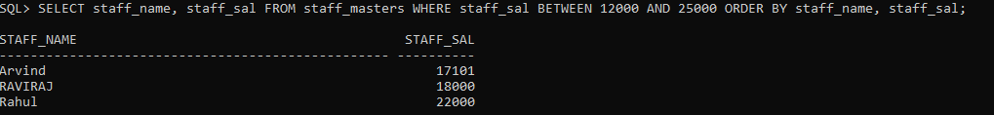

1. SELECT staff_name FROM staff_masters WHERE mgr_code IS NULL;

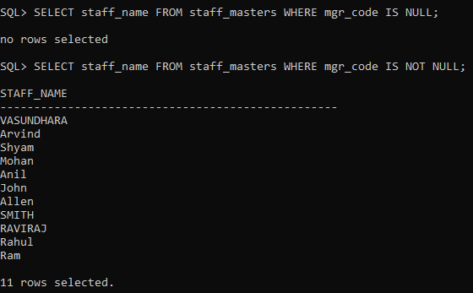

1. SELECT student_name, dept_code, student_dob FROM student_masters WHERE student_dob BETWEEN ´01-Jan-81´ AND ´31-Mar-83´ ORDER BY student_dob;

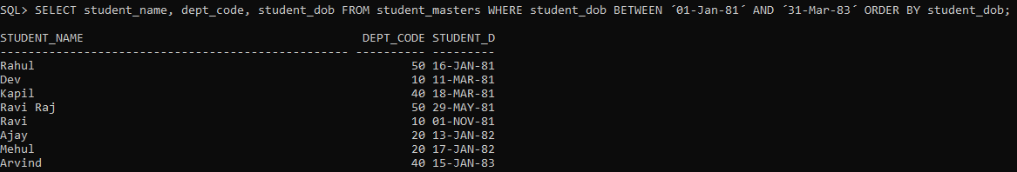

1. SELECT a.dept_code,SUM(a.staff_sal) FROM staff_masters a WHERE a.staff_code NOT IN(SELECT DISTINCT b.mgr_code FROM staff_masters b)GROUP BY a.dept_code HAVING SUM(a.staff_sal)>20000;

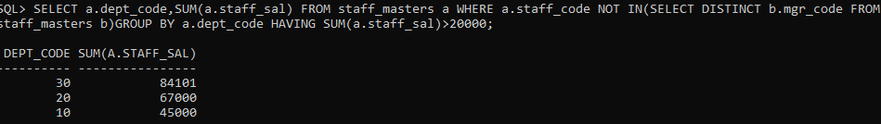

1. SELECT DISTINCT * FROM book_transactions WHERE book_actual_return_date IS NULL AND book_expected_return_date<(SELECT NEXT_DAY(´19-Feb-11´,´Monday´) FROM DUAL);

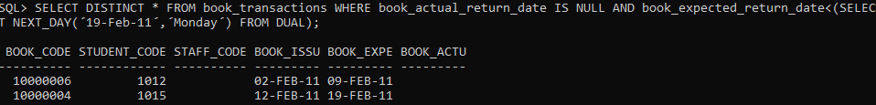

1. SELECT student_name, NVL(TO_CHAR(dept_code),´No Department´) AS DEPARTMENT FROM student_masters;

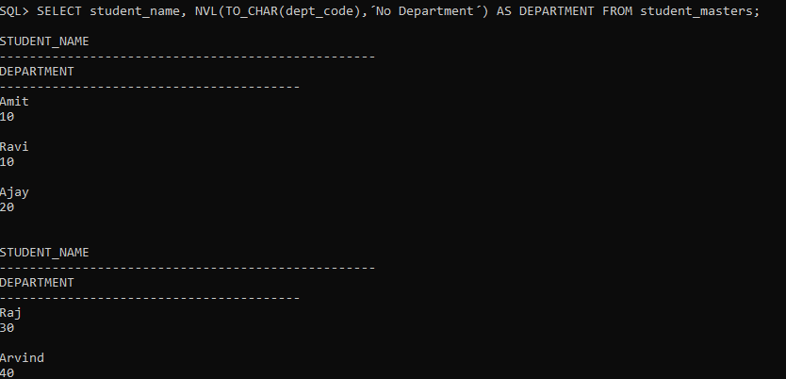

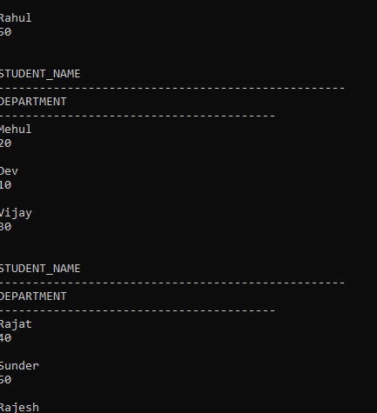

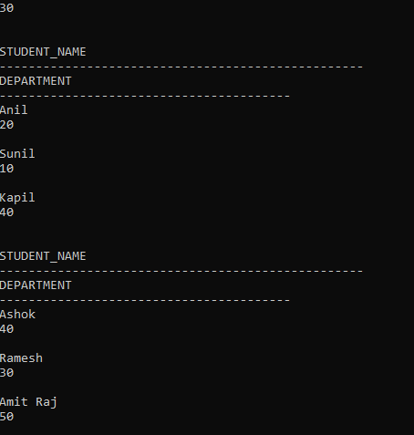

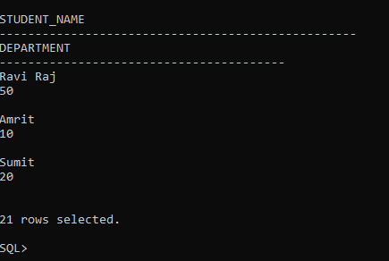

1. SELECT staff_name, staff_sal, RPAD(´X´,(staff_sal/1000),´X´) FROM staff_masters;

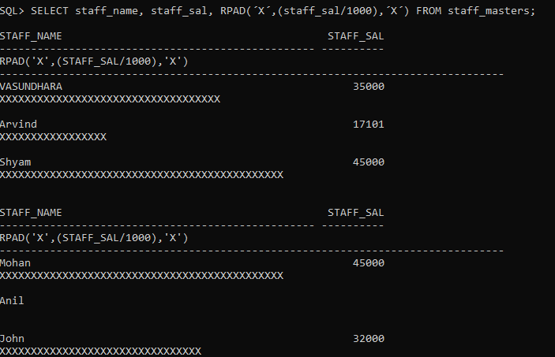

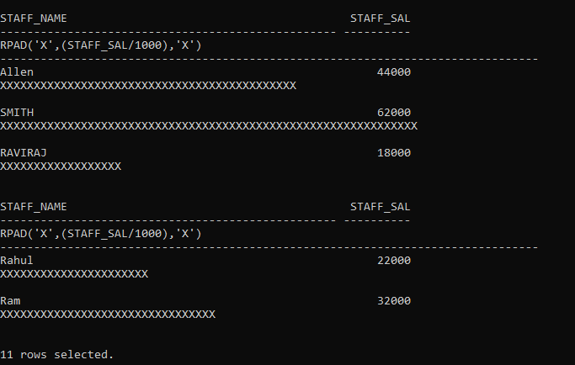

**LAB 2**

1. SELECT student_name, TO_CHAR(student_dob, ´Month, DD YYYY´) FROM student_masters WHERE TO_CHAR(student_dob, ´DAY´) LIKE ´%SUNDAY%´ OR TO_CHAR(student_dob,´DAY´) LIKE ´SATURDAY%´;

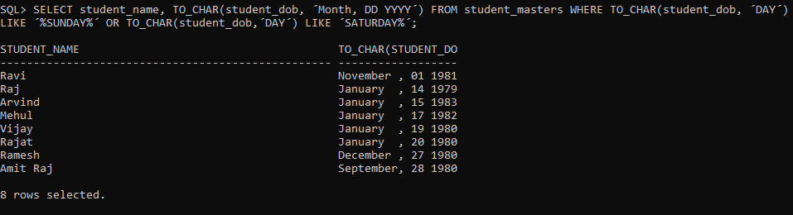

1. SELECT staff_name,ROUND(MONTHS_BETWEEN(sysdate,hiredate),-1) AS MONTHS_WORKED FROM staff_master ORDER BY MONTHS_WORKED;

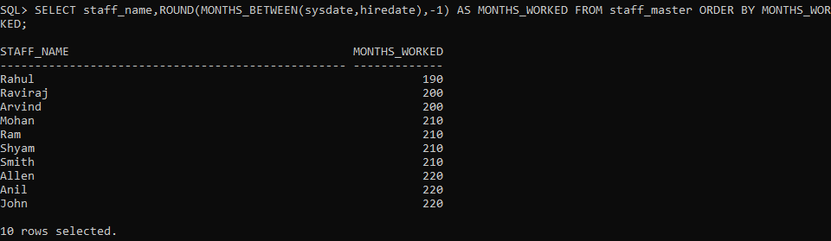

1. SELECT* FROM emp WHERE ename LIKE´A%S´;

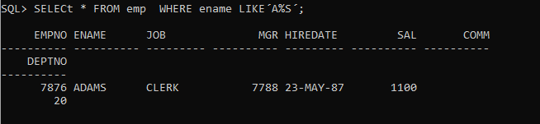

1. SELECT ename, job FROM emp WHERE (ename LIKE´_N´ OR ename LIKE´__N´) AND (ename LIKE´%N´ OR ename LIKE´%S´);



1. SELECT staff_name, LPAD(staff_sal,15,´$´) FROM staff_master;

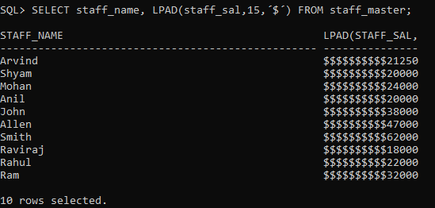

1. SELECT ename FROM emp WHERE ename LIKE ´%\_%´;



1. SELECT * FROM emp WHERE TO_CHAR(hiredate,´MM´) IN (12);

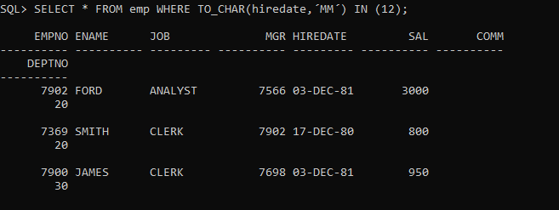

1. SELECT staff_name, staff_sal, CASE WHEN staff_sal >= 50000 THEN ´A´ WHEN staff_sal >= 25000 AND staff_sal < 50000 THEN ´B´ WHEN staff_sal >= 10000 AND staff_sal < 25000 THEN ´C´ ELSE ´D´ END AS grade FROM staff_master;

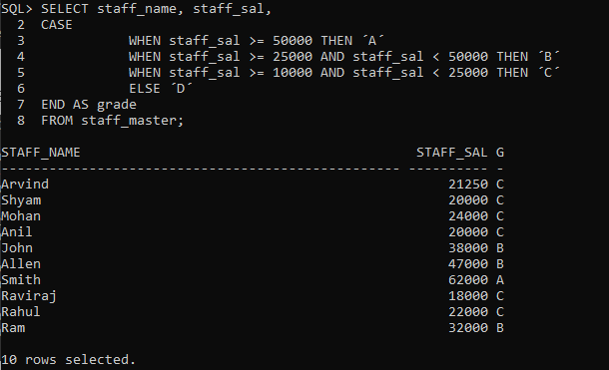

1. SELECT staff_name, hiredate, TO_CHAR(hiredate, ´DAY´) AS hireday FROM staff_master ORDER BY hireday;

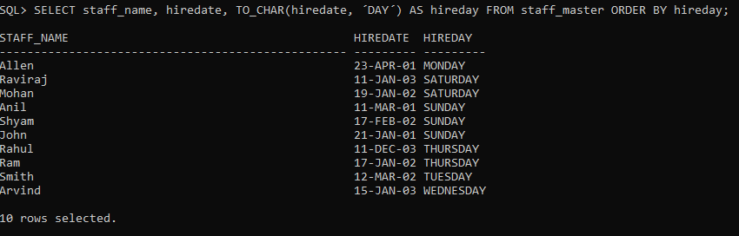

1. SELECT staff_name, LPAD(´*´, LENGTH(staff_name),´*´) AS ASTERIX FROM staff_master;

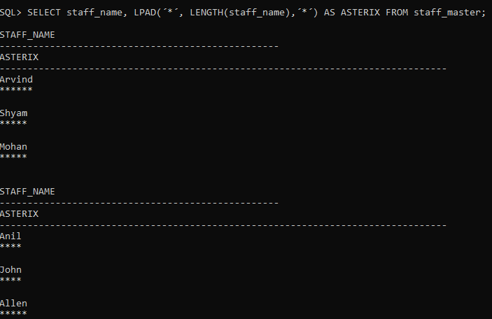

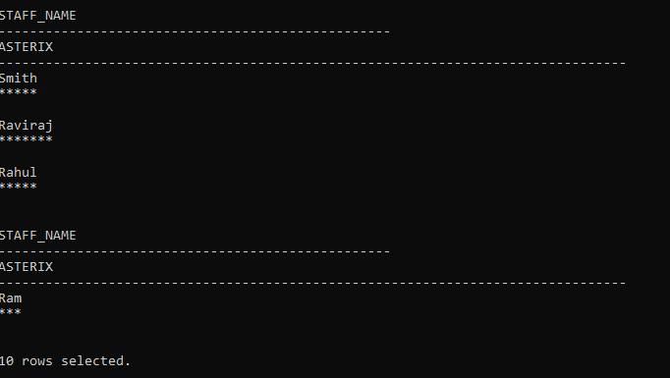

1. SELECT staff_name, SUBSTR(staff_name,1,1)|| RPAD(´*´,LENGTH(SUBSTR(staff_name,2,LENGTH(staff_name)-1)),´*´)|| SUBSTR(staff_name,LENGTH(staff_name),LENGTH(staff_name)) AS nams FROM staff_masters;

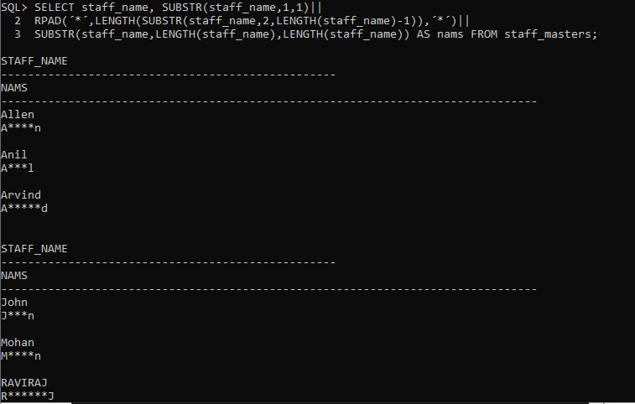

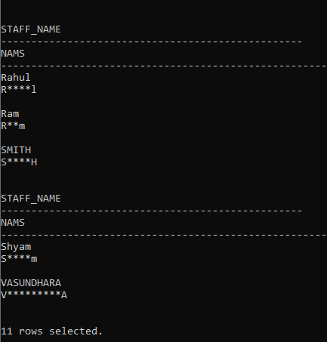

1. SELECT * FROM staff_master WHERE TO_CHAR(hiredate,´DD´) < 15;

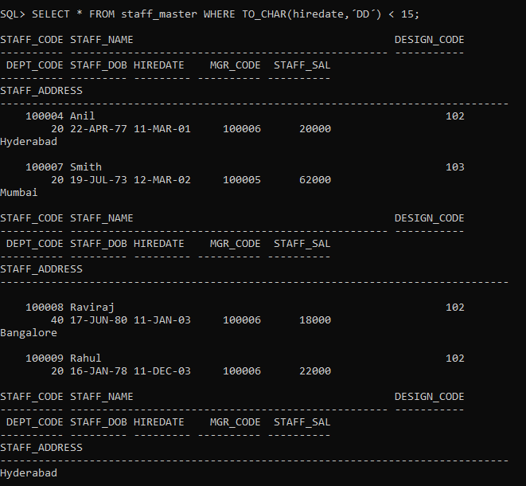

1. SELECT staff_name, hiredate, TO_CHAR(hiredate, ´DAY´) AS hireday FROM staff_master ORDER BY hireday;



1. SELECT INSTR(´Mississippi´,´i´,1,3) FROM DUAL;

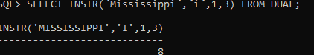

1. SELECT NEXT_DAY(LAST_DAY(sysdate) - INTERVAL ´7´ DAY, ´FRIDAY´) AS PAYDAY FROM DUAL;

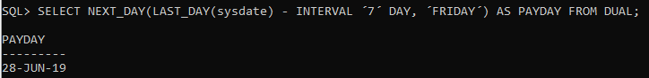

1. SELECT ROUND(MAX(staff_sal), -1) AS MAXIMUM,ROUND(MIN(staff_sal), -1) AS MINIMUM,ROUND(AVG(staff_sal), -1) AS AVERAGE FROM staff_masters;

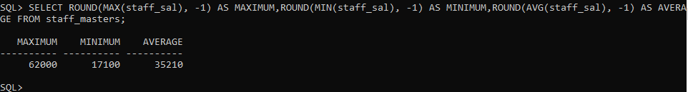

1. SELECT s.dept_code, d.dept_name, ROUND(MAX(s.staff_sal), -1) AS MAXIMUM,ROUND(MIN(s.staff_sal), -1) AS MINIMUM,ROUND(AVG(s.staff_sal), -1) AS AVERAGE FROM staff_masters s, department_masters d WHERE s.dept_code = d.dept_code GROUP BY d.dept_name, s.dept_code;

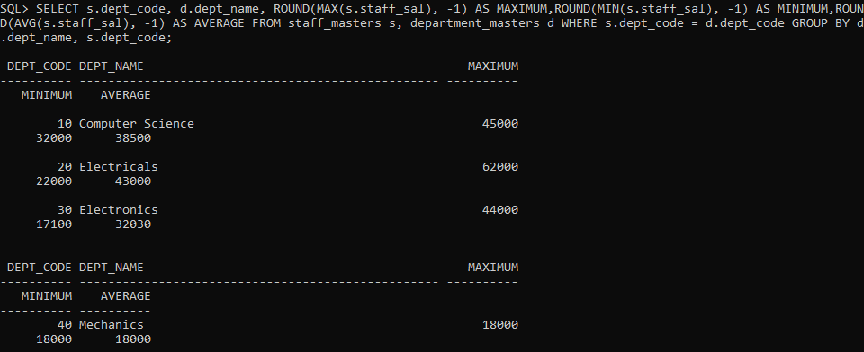

1. SELECT s.dept_code, d.dept_name, COUNT(s.staff_code) FROM staff_masters s, department_masters d WHERE s.dept_code = d.dept_code GROUP BY s.dept_code, d.dept_name;

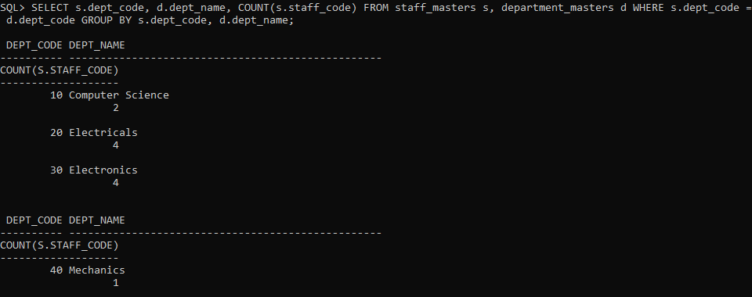

1. SELECT COUNT(DISTINCT mgr_code) AS TOTAL_NUMBER_OF_MANAGERS FROM staff_masters;

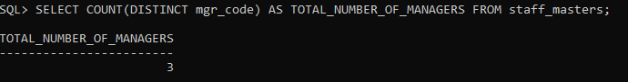

1. SELECT m.staff_code, m.staff_name, MIN(s.staff_sal) FROM staff_masters m, staff_masters s WHERE m.staff_code = s.mgr_code GROUP BY m.staff_code, m.staff_name HAVING MIN(s.staff_sal) > 10000 ORDER BY MIN(s.staff_sal) DESC;

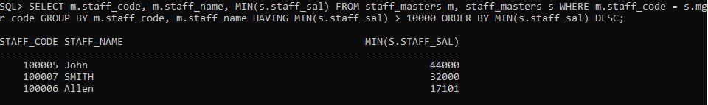

**LAB 3**

1. SELECT s.staff_name, s.dept_code, d.dept_name, s.staff_sal FROM staff_master s, department_master d WHERE s.dept_code = d.dept_code AND s.staff_sal > 20000;

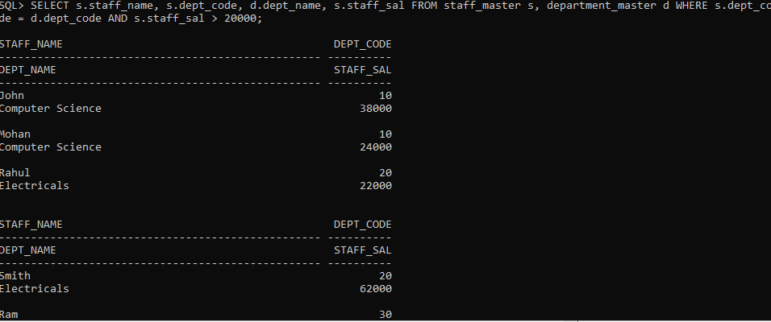

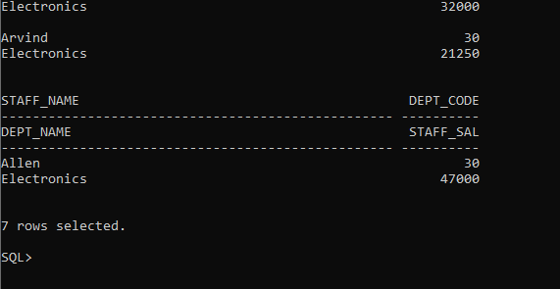

1. SELECT s.staff_name, s.dept_code, d.dept_name, s.staff_sal FROM staff_master s, department_master d WHERE s.dept_code = d.dept_code AND s.dept_code != 10 AND s.staff_name LIKE ´%A%´;

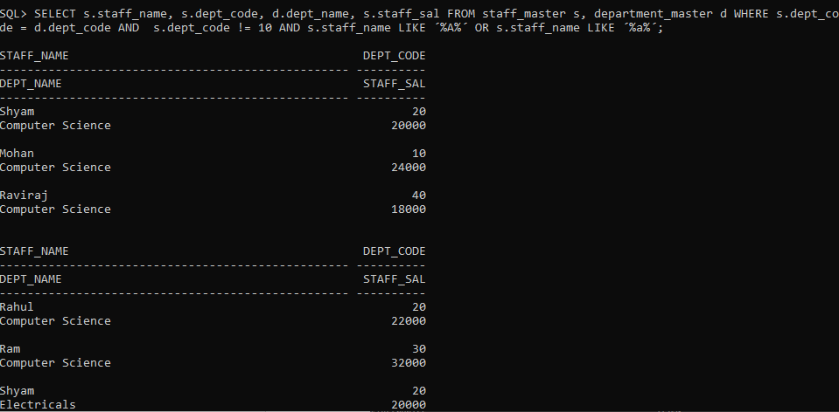

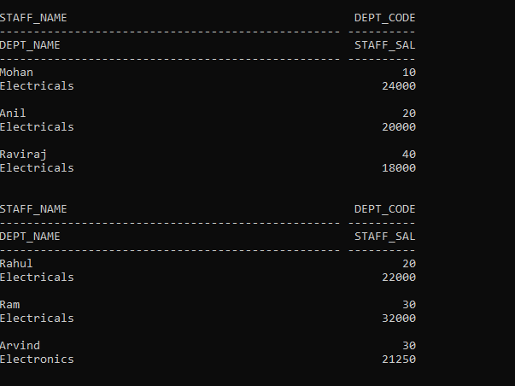

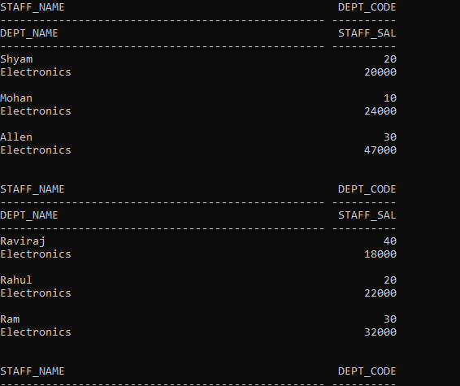

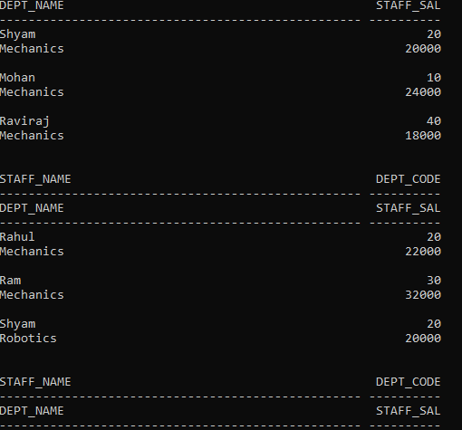

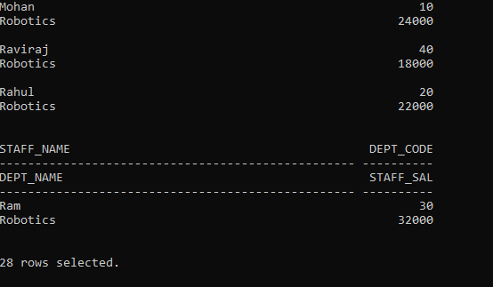

1. SELECT s.staff_code AS staff_code, s.staff_name AS staff_name, d.dept_name, s.staff_name, s.mgr_code AS mgr, ss.staff_name AS manager FROM staff_master s, department_master d, staff_master ss WHERE s.dept_code = d.dept_code AND s.mgr_code = ss.staff_code;

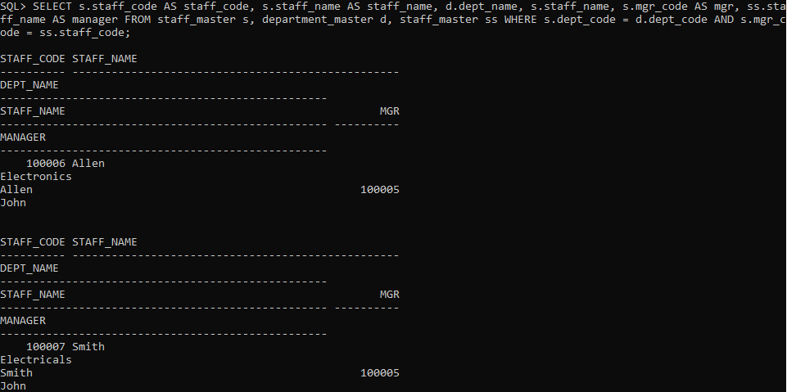

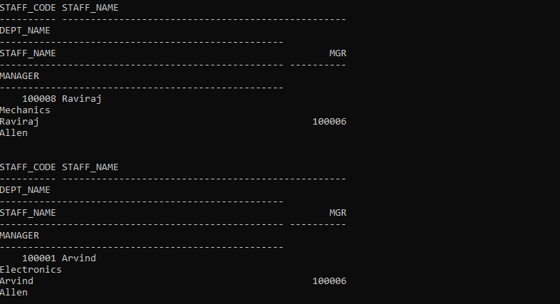

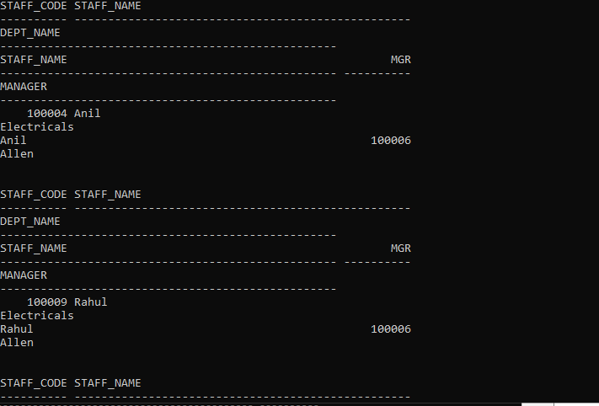

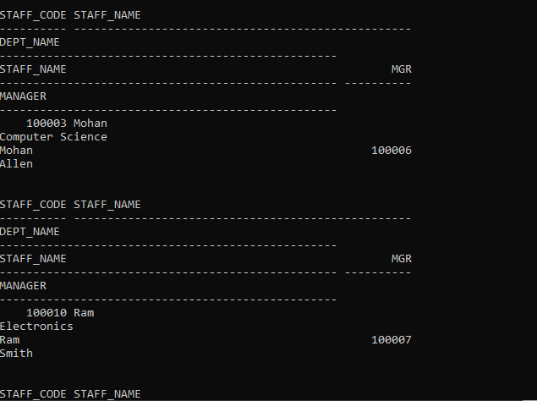

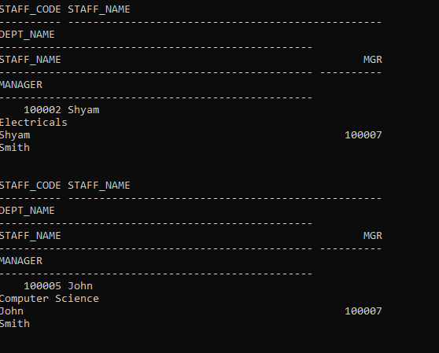

1. SELECT s.student_code, student_name, d.dept_name, m.subject1, m.subject2, m.subject3 FROM student_masters s, department_master d, student_marks m WHERE s.student_code = m.student_code AND s.dept_code = d.dept_code AND m.subject1 > 60 AND m.subject2 > 60 AND m.subject3 > 60 AND s.dept_code IN(10,20);

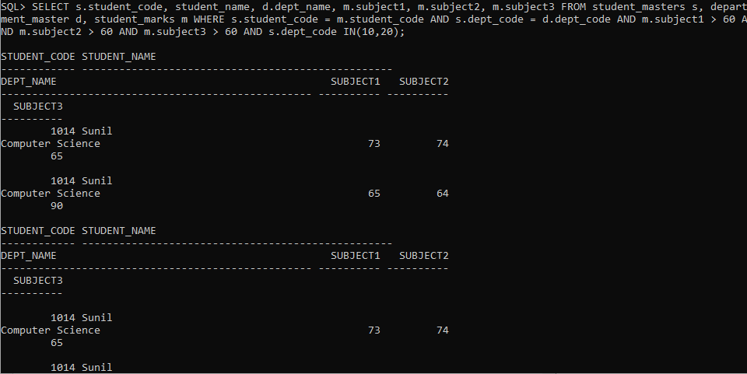 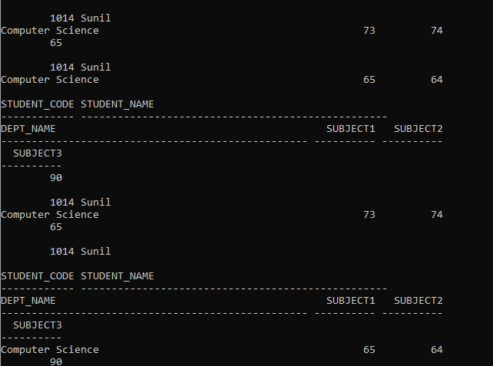

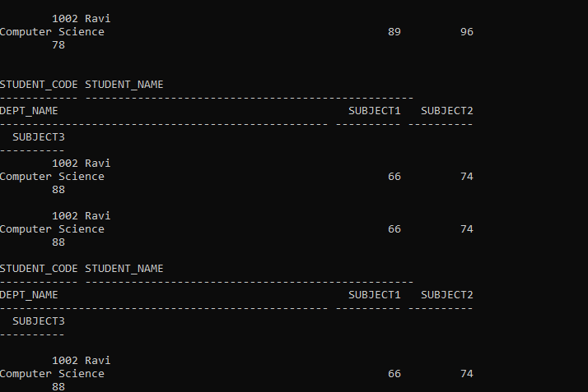

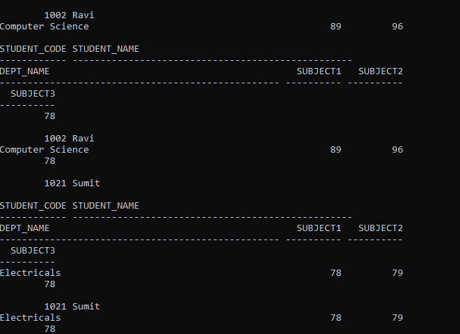

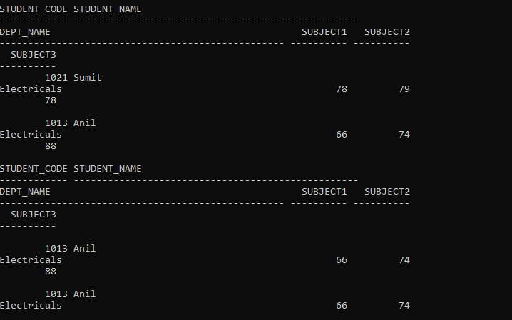

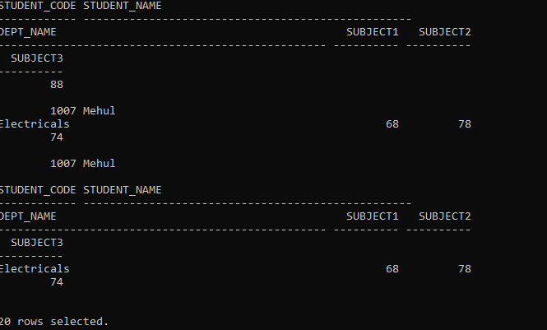

1. SELECT s.student_code, s.student_name, bt.book_code, b.book_name FROM book_masters b,book_transactions bt, student_masters s WHERE s.student_code = bt.student_code AND b.book_code = bt.book_code AND bt.book_expected_return_date = sysdate;



1. SELECT s.staff_code, s.staff_name, d.dept_name, s.design_code, bt.book_code, bt.book_issue_date FROM staff_master s, book_transactions bt, department_master d WHERE d.dept_code = s.dept_code AND bt.staff_code = s.staff_code AND bt.book_issue_date > sysdate - INTERVAL ´30´ DAY;



1. SELECT s.staff_code, s.staff_name, de.design_name, d.dept_name FROM staff_masters s, department_masters d, designation_masters de WHERE s.design_code = de.design_code AND s.dept_code = d.dept_code AND de.design_name != ´HOD´;

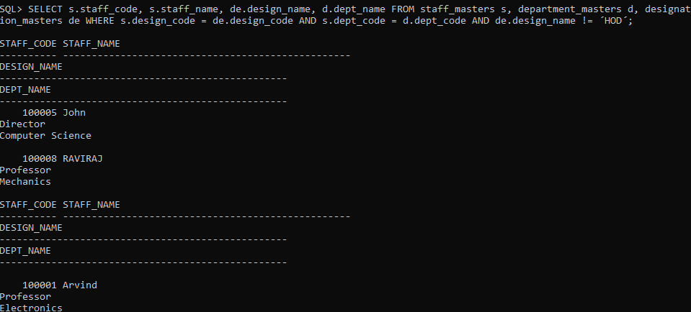

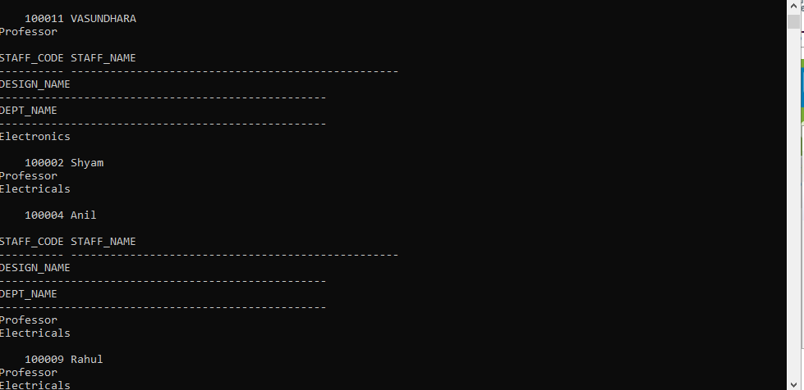

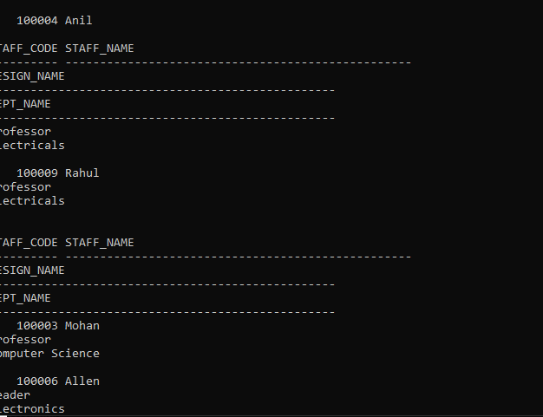

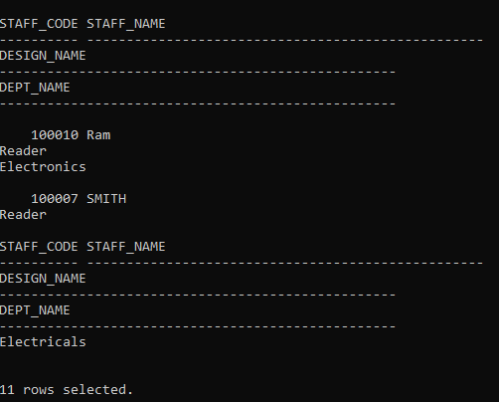

1. SELECT DISTINCT s.student_code, s.student_name, d.dept_name, (ss.subject1+ss.subject2+ss.subject3) AS total_marks FROM student_marks ss, student_masters s, department_masters d WHERE s.student_code = ss.student_code AND s.dept_code = d.dept_code ORDER BY d.dept_name,total_marks;

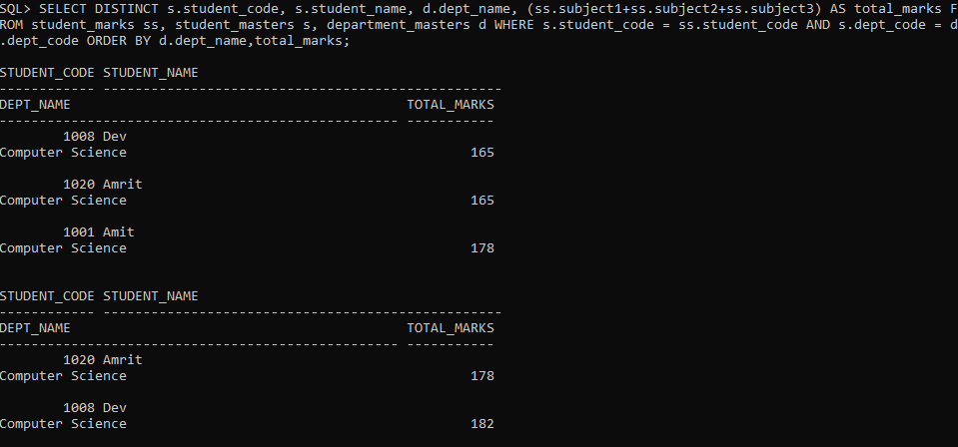

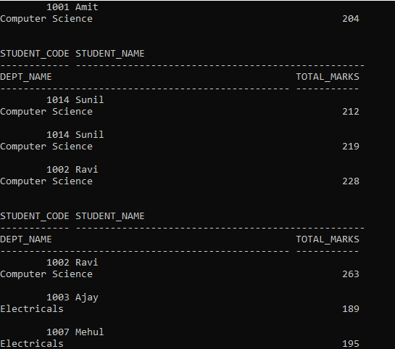

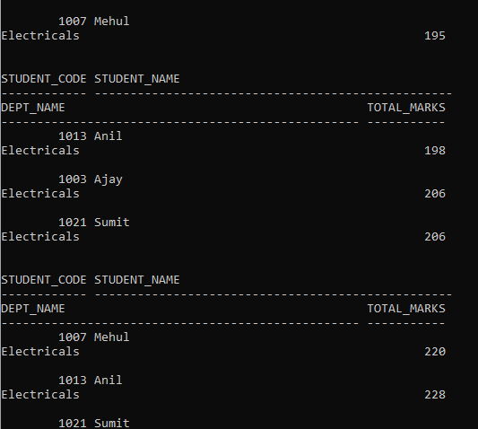

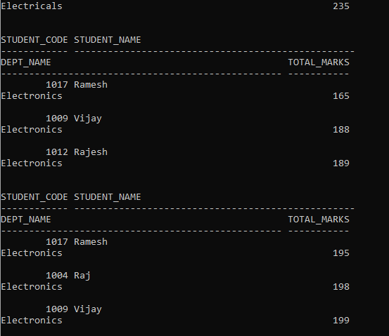

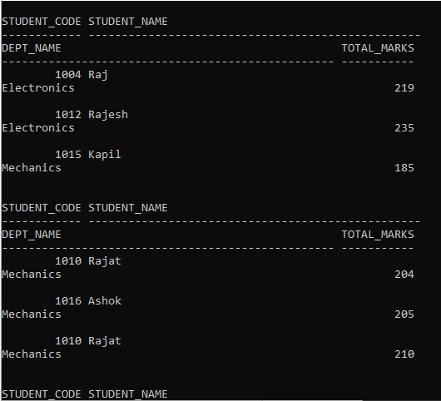

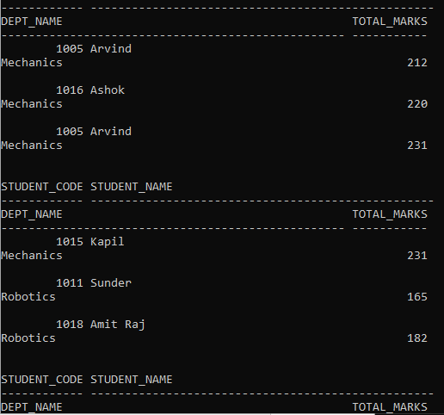

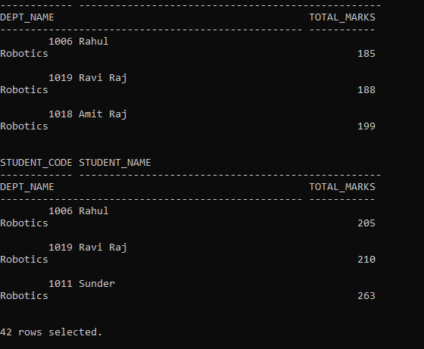

1. SELECT s.staff_code, s.staff_name, de.design_name, d.dept_name, b.book_code,

b.book_name, b.book_pub_author,

5*(sysdate - bt.book_expected_return_date) AS FINE

FROM staff_masters s, designation_masters de, department_masters d, book_masters b, book_transactions bt WHERE s.dept_code = d.dept_code AND

s.design_code = de.design_code AND s.staff_code = bt.staff_code AND

b.book_code = bt.book_code AND bt.book_actual_return_date IS NULL;

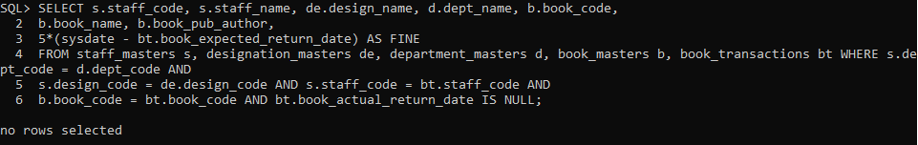

1. SELECT staff_code, staff_name, staff_sal FROM staff_masters WHERE staff_sal <(SELECT AVG(staff_sal) FROM staff_masters);

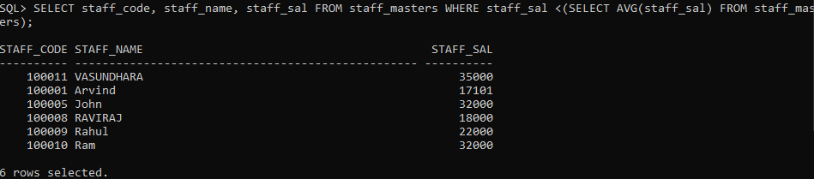

1. SELECT staff_code, staff_name FROM staff_masters WHERE staff_code NOT IN(SELECT mgr_code FROM staff_masters);

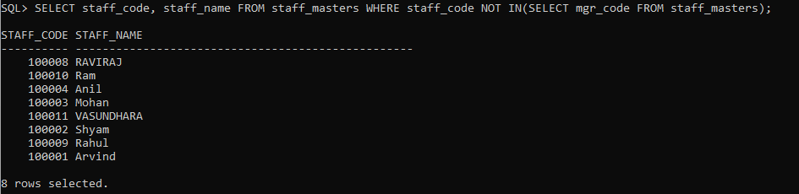

1. SELECT book_pub_author, book_name FROM book_masters WHERE book_pub_author IN(SELECT book_pub_author FROM book_masters GROUP BY book_pub_author HAVING COUNT(book_pub_author)>1);

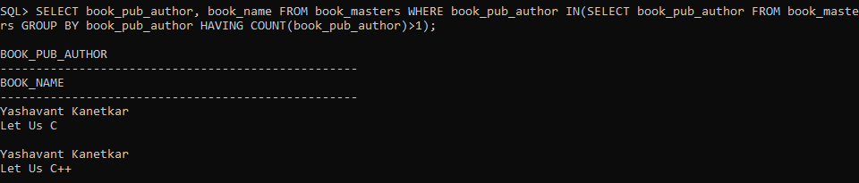

1. SELECT DISTINCT s.staff_code, s.staff_name, d.dept_name FROM staff_masters s, department_masters d, book_transactions bt WHERE s.staff_code = bt.staff_code AND s.dept_code = d.dept_code AND bt.staff_code > 1;

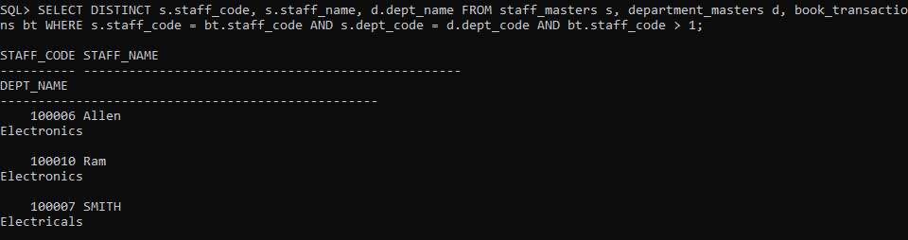

1. SELECT * FROM(

SELECT student_code,student_name,dept_code,subject1,subject2,subject3,subject1+subject2+subject3 AS total FROM student_masters NATURAL JOIN student_marks WHERE

dept_code=10 ORDER BY total DESC) WHERE ROWNUM<=10;

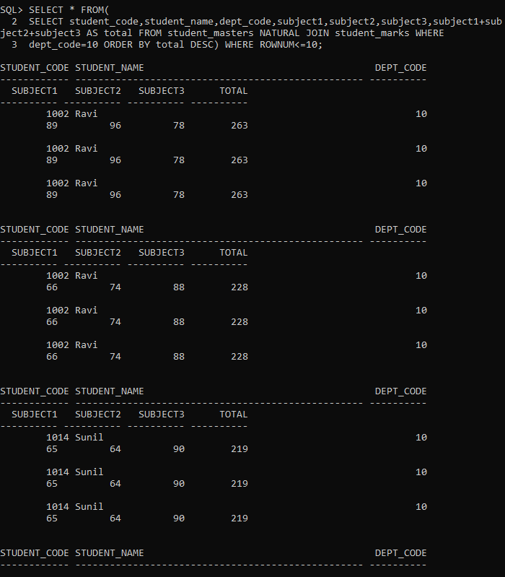

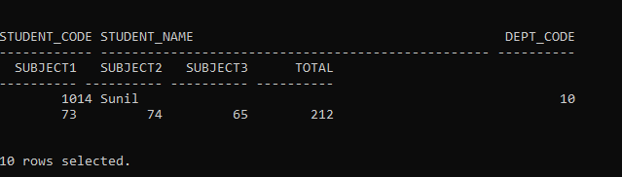

1. SELECT a.staff_name, b.dept_name,a.staff_sal FROM staff_masters a, department_masters b WHERE a.dept_code = b.dept_code AND a.staff_sal < (SELECT AVG(a.staff_sal) FROM staff_masters a);

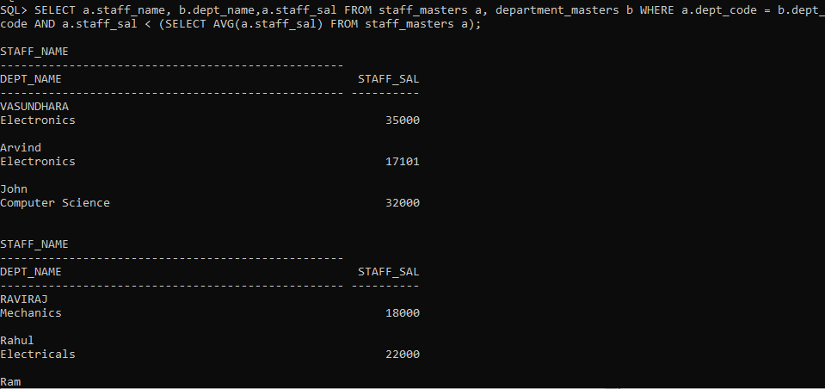

1. -
2. SELECT student_code,student_name FROM student_masters NATURAL JOIN student_marks WHERE dept_code=10 AND

student_dob=to_char(sysdate,´YYYY´) AND

subject1=(

SELECT MAX(subject1)FROM student_marks) AND

subject2=(

SELECT MAX(subject2)FROM student_marks) AND

subject3=(

SELECT MAX(subject3)FROM student_marks);

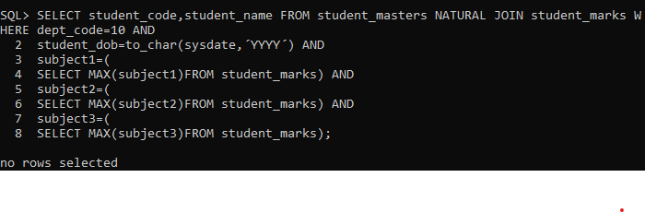

1. SELECT s.student_code, s.student_name, d.dept_name FROM student_masters s, department_master d WHERE s.dept_code = d.dept_code AND d.dept_code IN (

SELECT dept_code FROM student_masters GROUP BY dept_code HAVING COUNT(*) >= (

SELECT MAX(COUNT(*)) FROM student_masters GROUP BY dept_code));

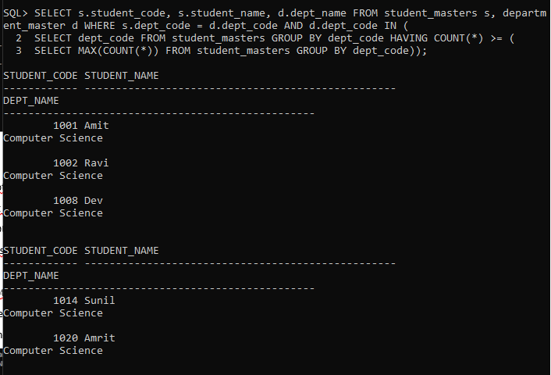

1. SELECT s.staff_code, s.staff_name, d.dept_name, de.design_name FROM staff_masters s, department_masters d, designation_masters de WHERE s.dept_code = d.dept_code AND s.design_code = de.design_code AND hiredate BETWEEN ´01-jan-2003´ AND ´28-jan-2003´;

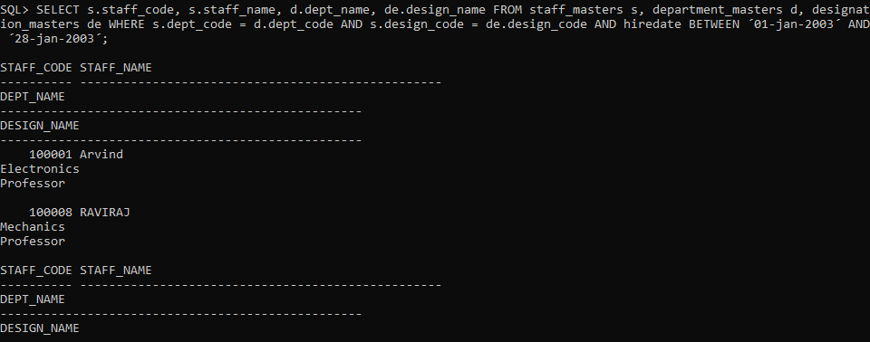

1. SELECT mgr_code, COUNT(staff_code) FROM staff_masters GROUP BY mgr_code;

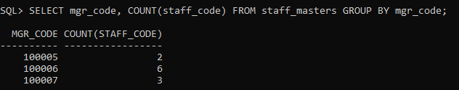

**LAB 3.2**

1. SELECT * FROM previous_products

UNION

SELECT * FROM current_products;

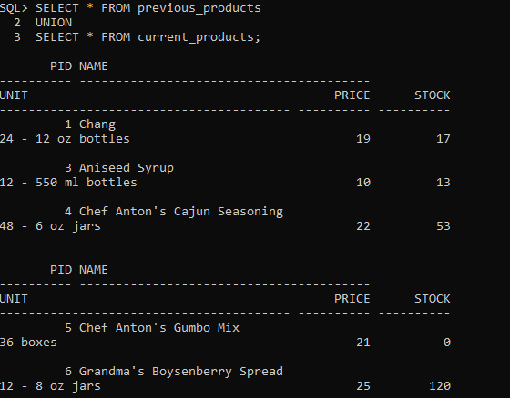

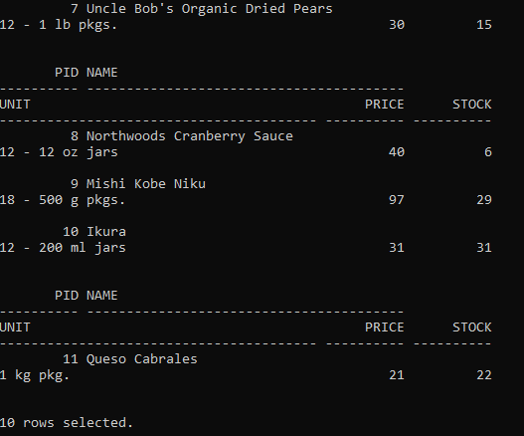

1. SELECT * FROM previous_products

UNION ALL

SELECT * FROM current_products;

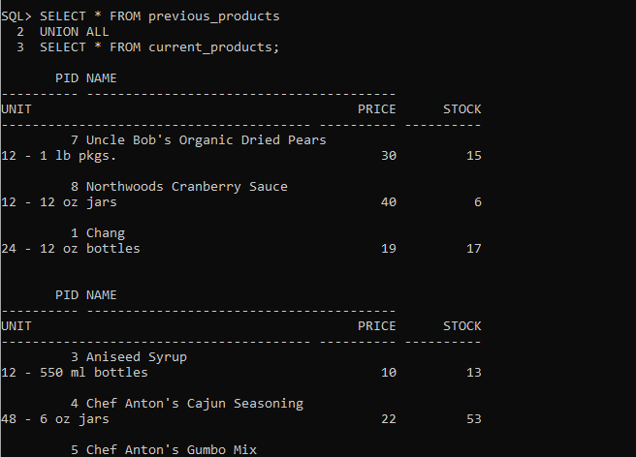

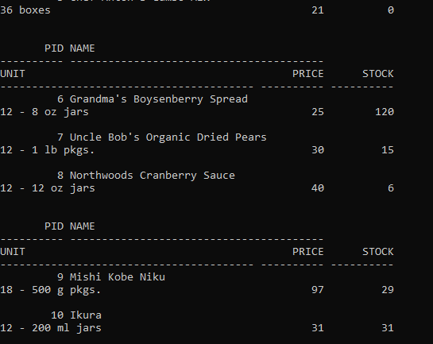

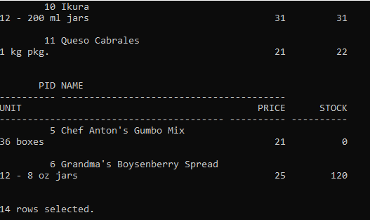

1. SELECT * FROM previous_products

INTERSECT

SELECT * FROM current_products;

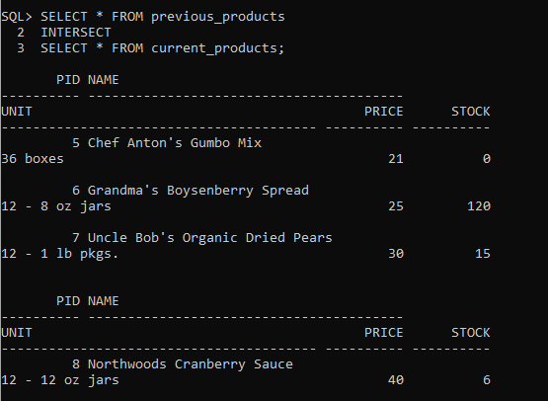



1. SELECT * FROM previous_products

MINUS

SELECT * FROM current_products;

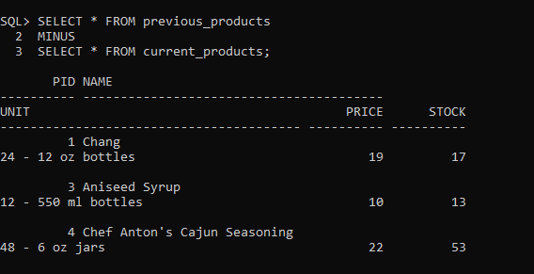

**LAB 4**

1. CREATE TABLE customer_table(

customer_id NUMBER(5), customer_name NUMBER(10), address1 VARCHAR2(30),

address2 VARCHAR2(30));

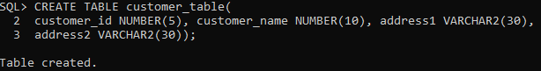

1. ALTER TABLE customer_table MODIFY

customer_name VARCHAR2(30);

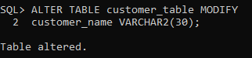

1. ALTER TABLE customer_table ADD(

gender VARCHAR2(1), age NUMBER(3), phone_no NUMBER(10));

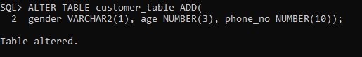

1. INSERT INTO customer_table VALUES(

1000, ´Allen´, ´#115 Chicago´, ´#115 Chicago´,´M´,25,7878776);

INSERT INTO customer_table VALUES(

1001, ´George´, ´#116 France´, ´#116 France´, ´M´, 25, 434524);

INSERT INTO customer_table VALUES(

1002, ´Becker´, ´#114 New York´, ´#114 New York´, ´M´, 45, 431525);

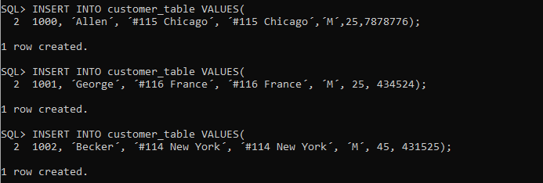

1. ALTER TABLE customer_table ADD CONSTRAINT

custid_pri PRIMARY KEY(customer_id);

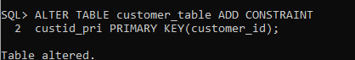

1. INSERT INTO customer_table VALUES(

1002, ´John´, ´#114 Chicago´, ´#114 Chicago´, ´M´, 45, 439525 );

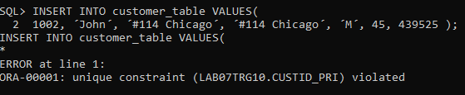

1. ALTER TABLE customer_table

DISABLE CONSTRAINT custid_pri;

INSERT INTO customer_table VALUES(

1002, ´Becker´, ´#114 New York´, ´#114 New york´, ´M´, 45, 431525);

INSERT INTO customer_table VALUES(

1003, ´Nanapatekar´, ´#115 India´, ´#115 India´, ´M´, 45, 431525);

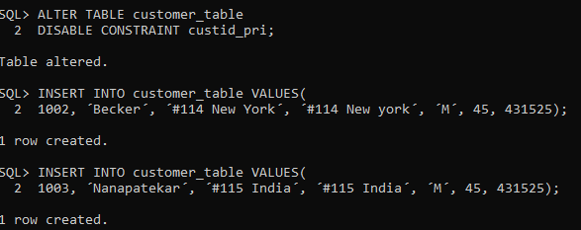

1. ALTER TABLE customer_table

ENABLE CONSTRAINT custid_pri;

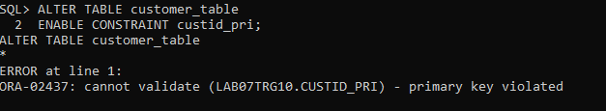

1. ALTER TABLE customer_table

DROP CONSTRAINT custid_pri;

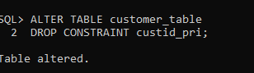

ALTER TABLE customer_table ADD(

cust_sal NUMBER(10));

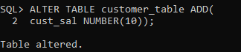

INSERT INTO customer_table VALUES(

1002, ´Becker´, ´#114 New York´, ´#114 New york´, ´M´, 45, 431525, 15000.50);

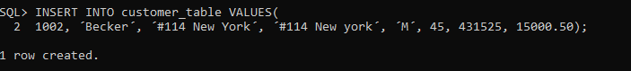

INSERT INTO customer_table VALUES(

1003, ´Nanapatekar´, ´#115 India´, ´#115 India´, ´M´, 45, 431525, 20000.50);

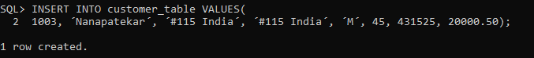

1. TRUNCATE TABLE customer_table;



1. ALTER TABLE customer_table ADD(

E_mail VARCHAR(20));

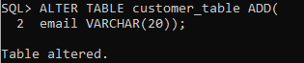

1. ALTER TABLE customer_table

DROP COLUMN E_mail;

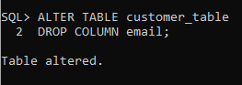

1. ALTER TABLE customer_table ADD(

EmailId VARCHAR(20));

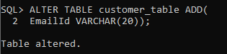

1. ALTER TABLE customer_table

SET UNUSED (emailId);

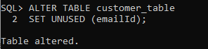

1. ALTER TABLE customer_table

DROP UNUSED COLUMNS;

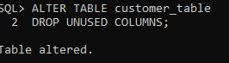

1. COMMENT ON TABLE customer_table IS ´Customer Details´;



1. SELECT * FROM USER_TAB_COMMENTS WHERE table_name = ´CUSTOMER_TABLE´;

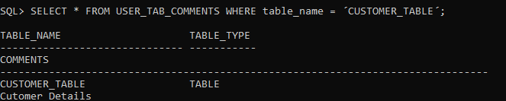

1. COMMENT ON COLUMN customer_table.phone_no IS ´Personal Contact no´;



1. SELECT * FROM USER_COL_COMMENTS WHERE table_name = ´CUSTOMER_TABLE´;

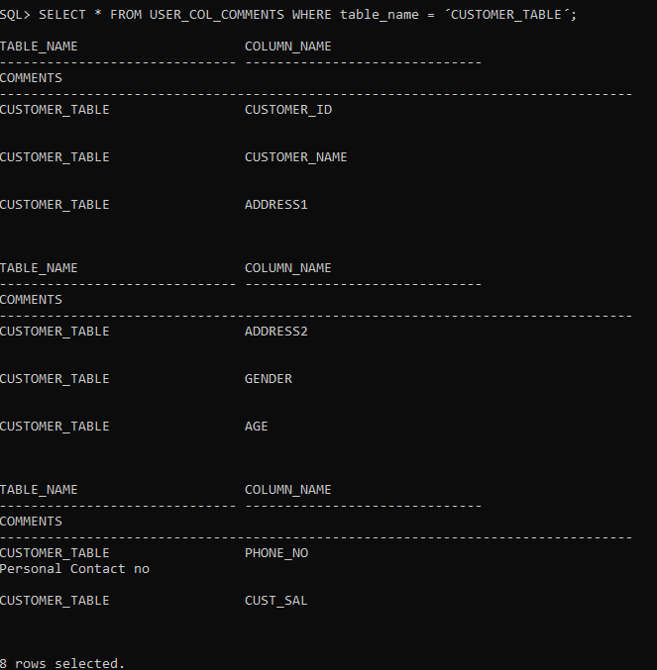

1. CREATE TABLE suppliers AS SELECT customer_id AS suppid, customer_name AS sname, address1 AS addr1, address2 AS addr2, phone_no AS contactno FROM customer_table;

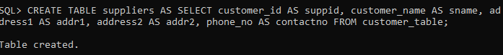

1. CREATE TABLE customermasters(

customerid NUMBER(5),

customername VARCHAR2(30) NOT NULL,

address1 VARCHAR2(30) NOT NULL,

gender VARCHAR2(1), age NUMBER(3),

phoneno NUMBER(10), CONSTRAINT custid_PK PRIMARY KEY (customerid));

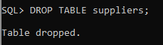

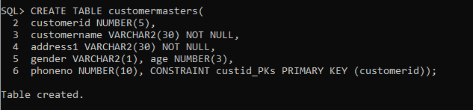

1. CREATE SEQUENCE acc

START WITH 1000

INCREMENT BY 1

CACHE 20;

CREATE TABLE accountsmasters(

custid NUMBER(5), accountno NUMBER(10,2)

CONSTRAINT acc_prim PRIMARY KEY,

account_type VARCHAR2(3), ledgerbalance NUMBER(10,2) NOT NULL);

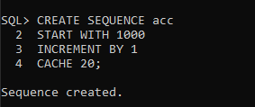

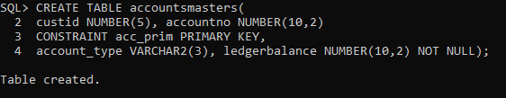

1. ALTER TABLE accountsmasters ADD CONSTRAINT cust_acc FOREIGN KEY(custid) REFERENCES customermasters(customerid);

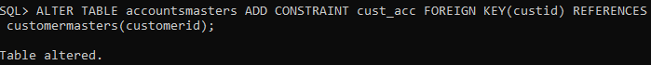

1. INSERT INTO customermasters VALUES(

1000,´Allen´, ´#115 Chicago´, ´M´, 25, 7878776, ´#115 Chicago´);

INSERT INTO customermasters VALUES(

1001,´George´, ´#116 Chicago´, ´M´, 25, 434524, ´#116 Chicago´);

INSERT INTO customermasters VALUES(

1002,´Becker´, ´#114 New York´, ´M´, 25, 431525, ´#114 New York´);

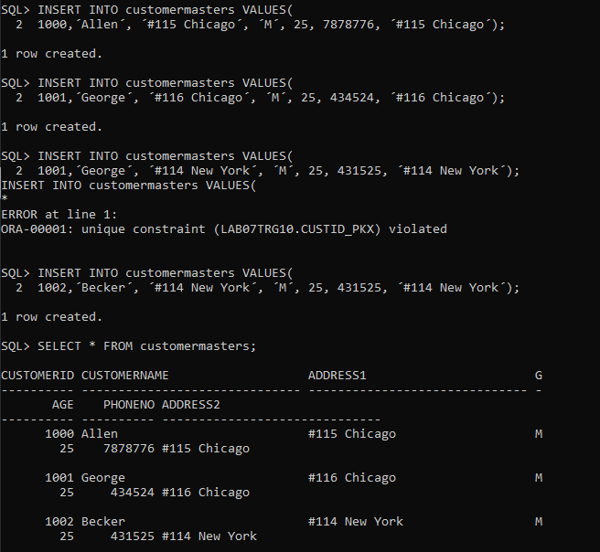

1. ALTER TABLE accountsmasters MODIFY account_type CHECK(account_type IN(´NRI´,´IND´));

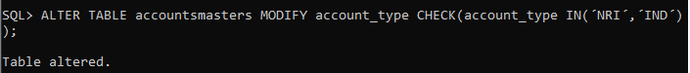

1. INSERT INTO accountsmasters VALUES(

1000,acc.nextval,´IND´,17000);

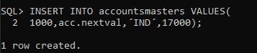

1. ALTER TABLE accountsmasters ADD CONSTRAINTS balance_check check(ledgerbalance>5000);

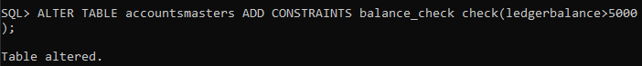

1. CREATE TRIGGER acc_trigger

AFTER

DELETE ON customermasters

FOR each row

BEGIN

DELETE FROM accountsmasters WHERE customermasters.customerid=accountsmasters.custid;

END;

/

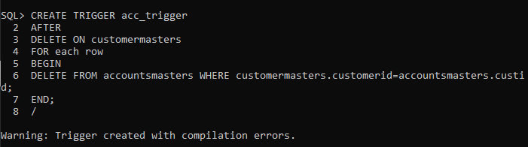

1. CREATE TABLE accounts_details AS SELECT * FROM accountsmasters;



1. RENAME accounts_details TO backup_table;

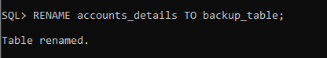

1. CREATE VIEW acc_view (

customer_code, accountholder_name,account_number,type,balance)

AS

SELECT customerid, customername, accountno, account_type, ledgerbalance

FROM accountsmasters NATURAL JOIN customermasters;

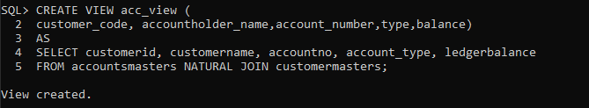

1. CREATE VIEW vaccs_dtls AS

SELECT * FROM accountsmasters WHERE

account_type=´IND´ and ledgerbalance>=10000;

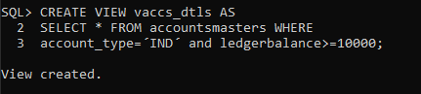

1. CREATE VIEW accsvw10 AS

SELECT SUM(ledgerbalance) AS

TOTAL FROM accountsmasters;

SELECT * FROM accsvw10;

UPDATE accsvw10 SET total=20000;

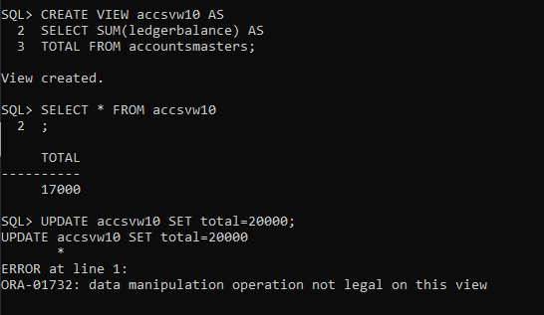

1. SELECT * FROM(

SELECT dept_name FROM staff_master NATURAL JOIN department_masters

ORDER BY staff_sal DESC)

WHERE ROWNUM<2;

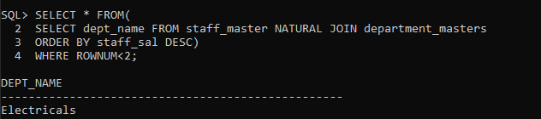

1. -
2. CREATE sequence seq_dept

START WITH 40

INCREMENT BY 10

MAXVALUE 200;

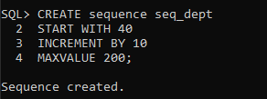

1. INSERT INTO dept VALUES(

seq_dept.nextval,´MACHINES´,´INDIA´);

INSERT INTO dept VALUES(

seq_dept.nextval,´ACCOUNTING´,´DALLAS´);

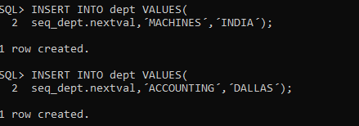

1. ALTER SEQUENCE seq_dept INCREMENT BY 5;

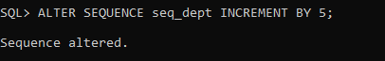

1. DROP SEQUENCE seq_dept;



1. CREATE unique index no_name ON dept(deptno, dname);

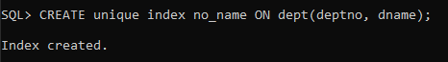

1. SELECT index_name,index_type,table_owner,table_name,uniqueness FROM user_indexes WHERE index_name=´NO_NAME´;

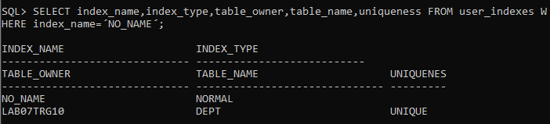

1. CREATE SYNONYM synEmpx FOR emp;

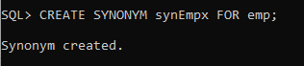

1. SELECT * FROM user_synonyms WHERE synonym_name=´SYNEMP´;

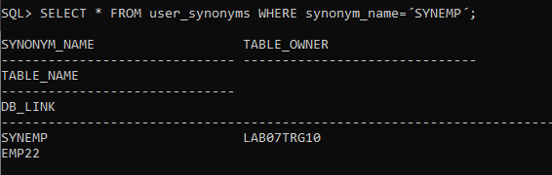

**LAB 5**

1. create table employeee as select * from emp where 1=3;

desc employeee;

select * from employeee;

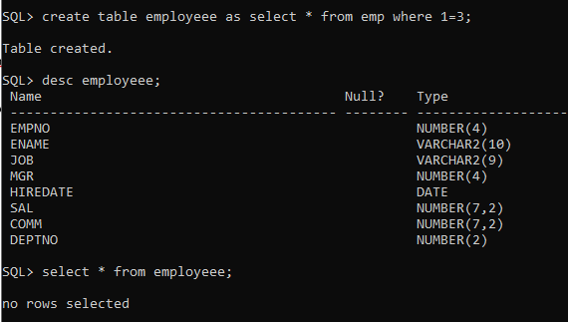

1. insert into employeee(empno,ename,sal,deptno) select empno,ename,sal,deptno from emp;

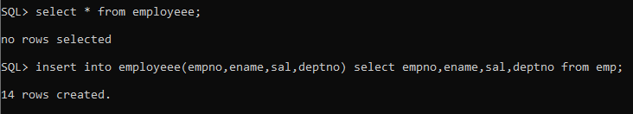

1. update employeee set job=(select job from employeee where empno=7788),deptno=(select deptno from employeee where empno=7788) where empno=7698;



1. delete from department1 where dept_name = ´sales´;



1. update employeee set deptno=(select deptno from employeee where empno=7698) where empno=7788;



1. insert into employeee values(&empno,&ename,&job,&mgr,&hiredate,&sal,&comm,&deptno);

Enter value for empno: 1000

Enter value for ename: ´allen´

Enter value for job: ´clerk´

Enter value for mgr: 1001

Enter value for hiredate: ´12-Jan-2001´

Enter value for sal: 3000

Enter value for comm: 2

Enter value for deptno: 10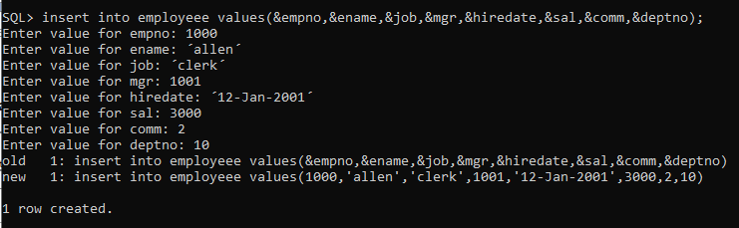

**LAB 6**

1. insert into customer_masters values(&customer_id,&customer_name,&address,&gender,&age,&phone_no,&income);

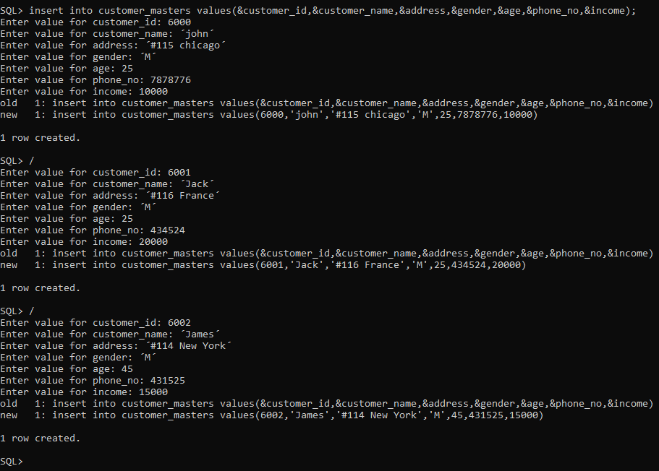

1. savepoint sp1;

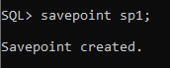

1. insert into customer_masters values(6003,'John','#114 chicago','M',45,439525,19000);



1. rollback to sp1;

